**1.Title: Online Travel Guide using AI**

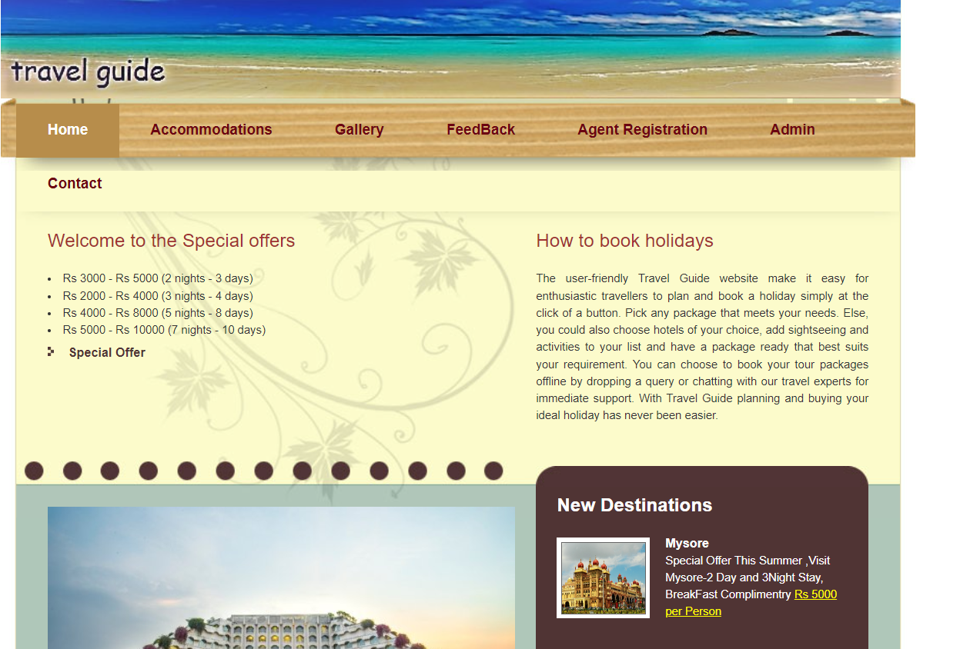

**2.Project Statement:**

The project aims to develop a user-friendly web application that facilitates the

n proposed System, Holiday Trip Planner is designed in such a way in which the

publisher can publish holiday packages. These packages are appears at all existing users in

the site. The user can inte

tourists in planning their tour of a completely anonymous place he wants to explore. This website plans the tour such that the user can save more time in exploring maximum places rather than wasting time in reaching his destinations.  It takes the information such as location, the list of places the user wants to visit, the start and end place of the tour to make the plan. The tourist place list will be displayed on customer speech. The application will recognise the voice and display the tourist place.

**Outcomes:**

It will show the list of places of attractions of that place from which the user can opt the places of his choice according to his priority. Then it takes the start and the end place of the tour. After making an analysis of the distances between all the places into account a route map with the shortest possible path is displayed.

This website is very useful to all the people who love to travel in planning a time efficient trips where he or she can save time to visit new places rather than getting lost in an unaware place.

Enhance patient satisfaction by offering a seamless and user-friendly interface. The tourist place list will be displayed on customer speech. The application will recognise the voice and display the tourist place.

1. **Modules to be implemented**
2. User Authentication and Registration
3. Customer voice recognization
4. Appointment Scheduling Interface
5. Place Availability Management
6. Place Information Management
7. Booking Management
8. Notification System
9. Admin Dashboard
10. **Week-wise module implementation and high-level requirements with output screenshots**

**Milestone 1: Weeks 1-3**

**Module 1: User Authentication and Registration**

* Implement user registration functionality.
* Develop user login mechanism.
* Integrate email verification and password reset features.
* The tourist place list will be displayed on customer speech. The application will recognise the voice and display the tourist place.
* Output screenshoot:

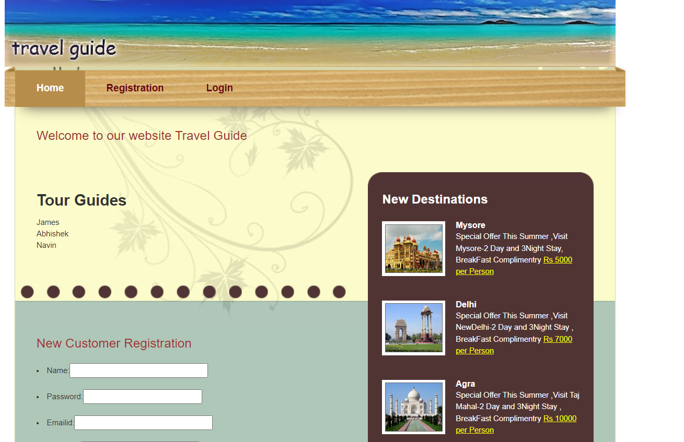

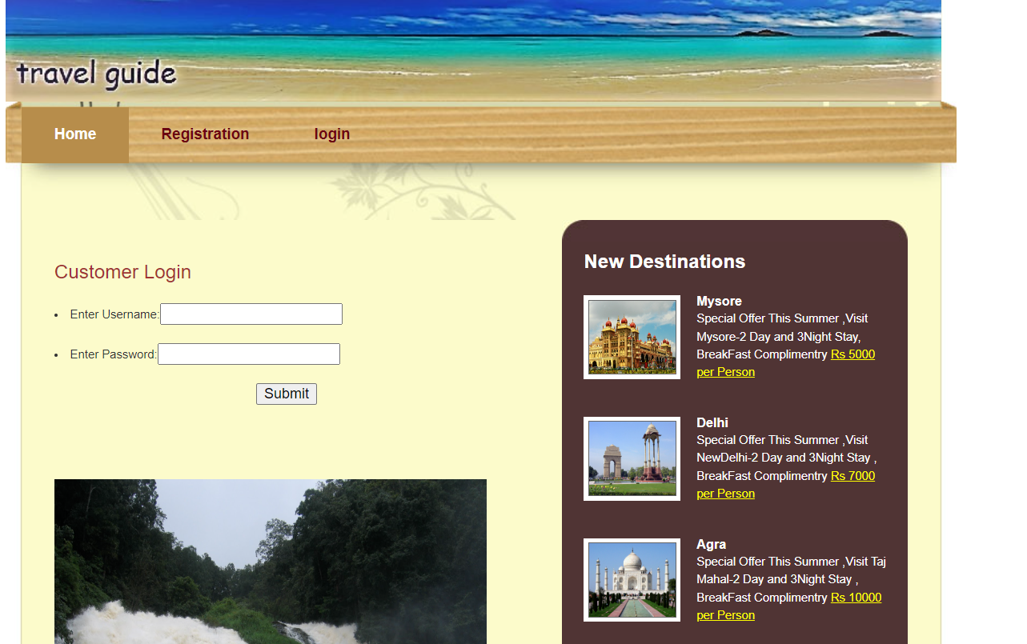

**Module 2: Place Availability Management**

* Design database schema for storing doctor availability information.
* Develop an interface for Tour Locations to set their availability.
* Implement backend functionality to manage and update hotel availability.
* Output screenshot

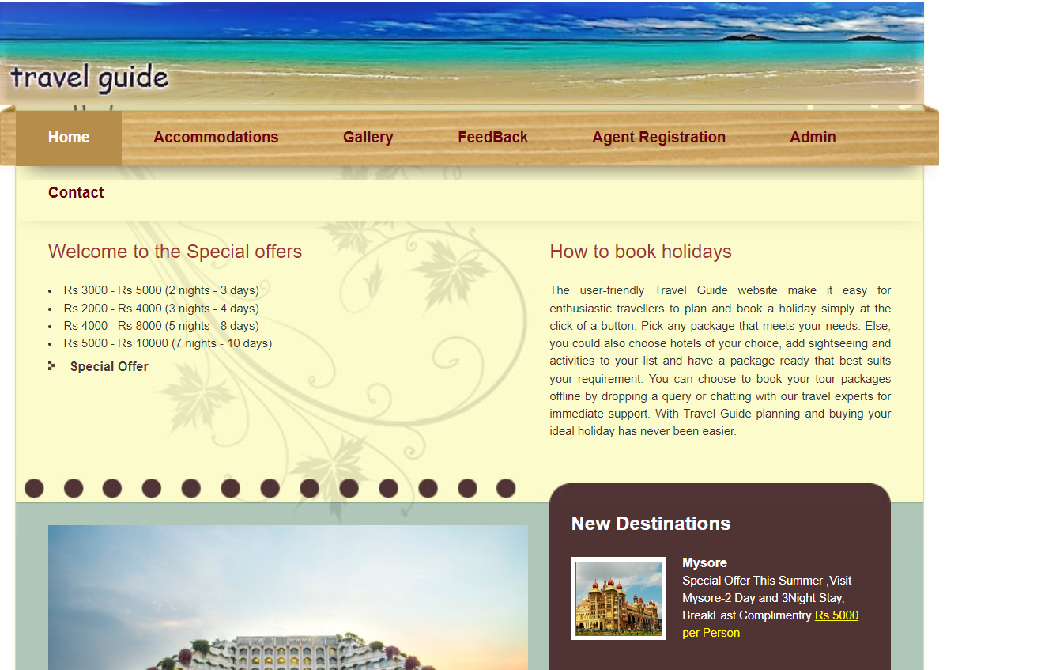

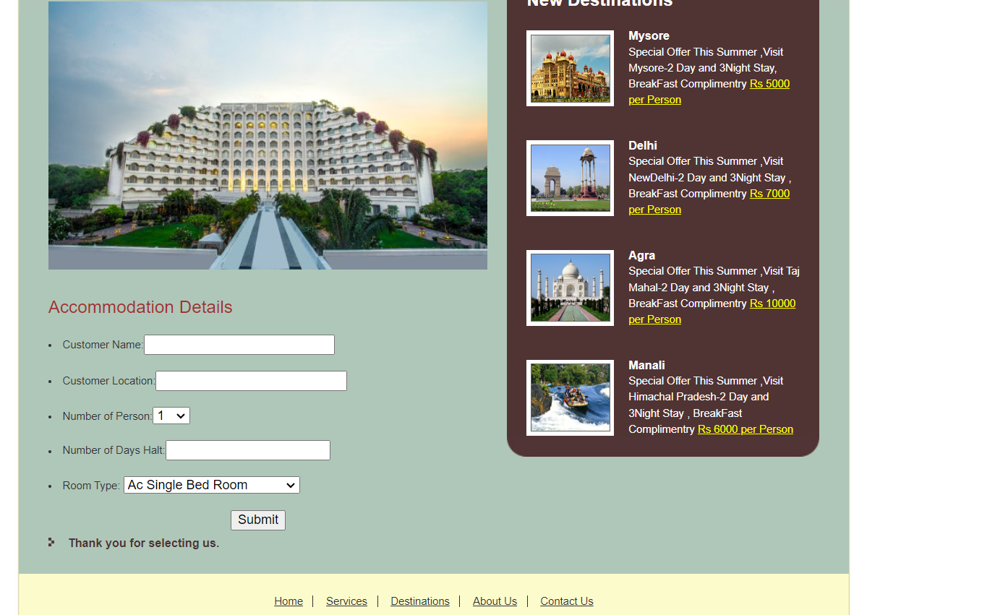

**Milestone 2: Weeks 4-5**

**Module 3: Booking Scheduling Interface**

* Design and develop the interface for appointment scheduling.
* Implement functionality for users to select place, preferred to visit, and time for the visit.
* Integrate the scheduling interface with the backend for storing appointment details.
* Output screenshot

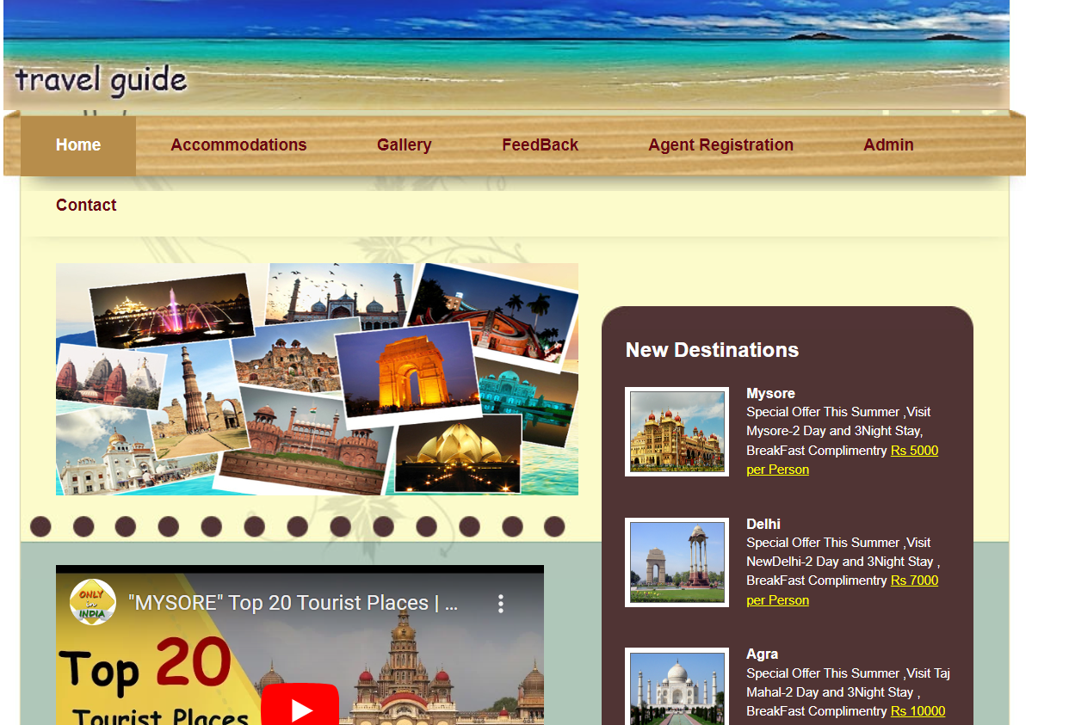

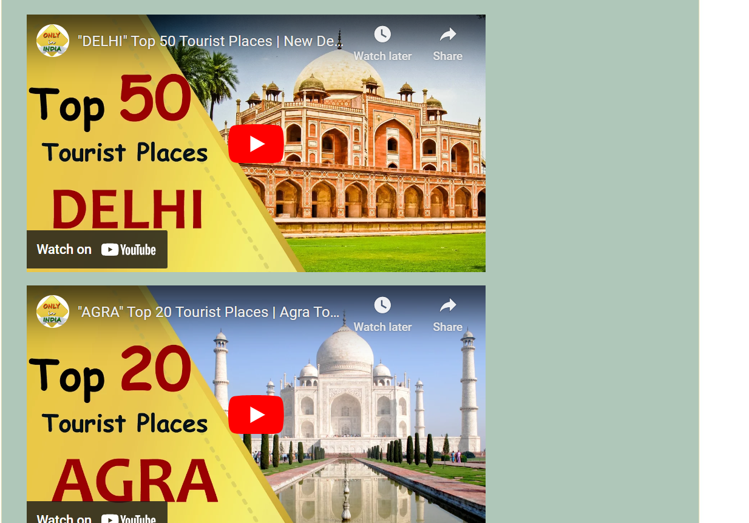

**Milestone 3: Weeks 6-7**

**Module 4: Appointment Management**

* Design database schema for storing appointment details.
* Implement backend functionality for scheduling appointments and preventing conflicts.
* Develop an interface for customers to view and manage visits.
* Output Screenshot:

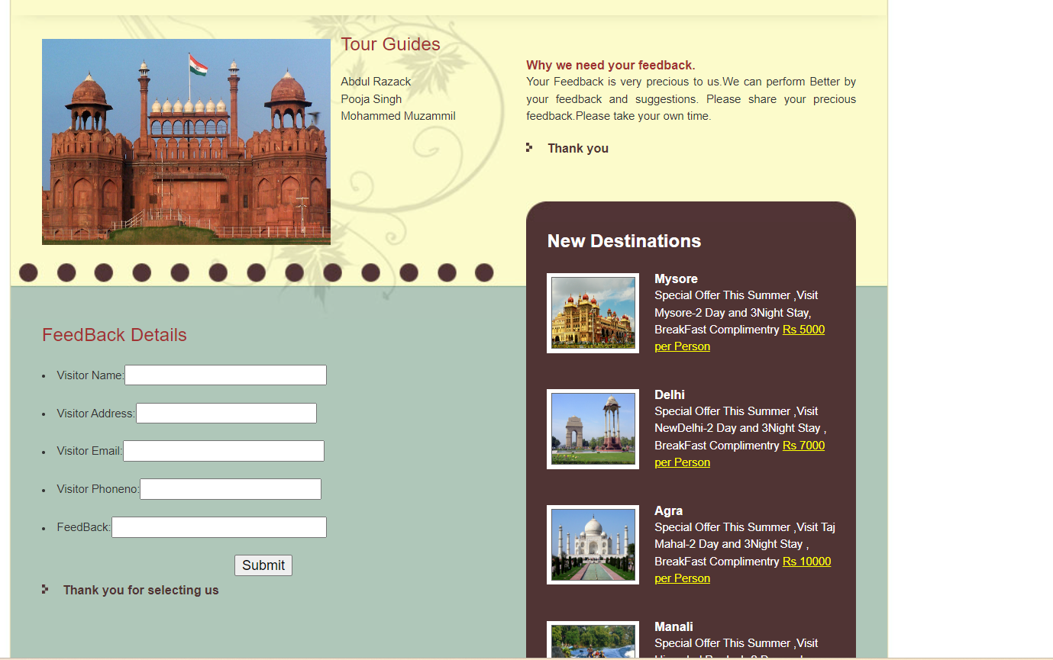

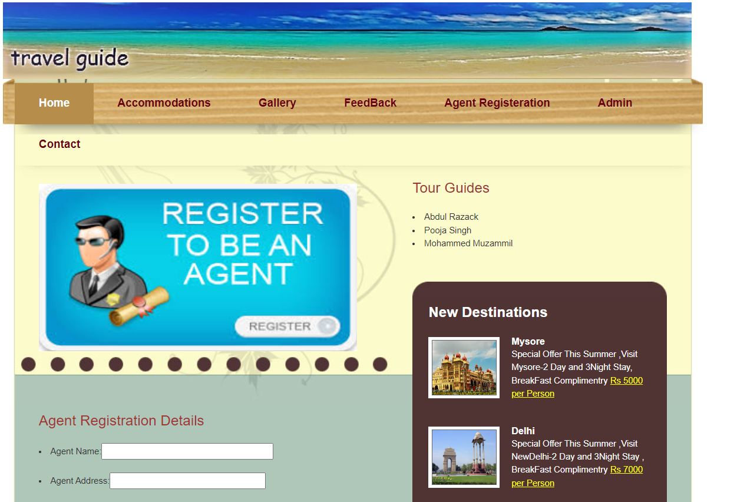

**Milestone 4: Weeks 8-10**

**Module 5: Place Information Management**

* Design database schema for storing patient information securely.
* Develop functionality for customers to provide and update their information.
* Implement backend logic for accessing and managing patient information securely.
* Output Screenshot:

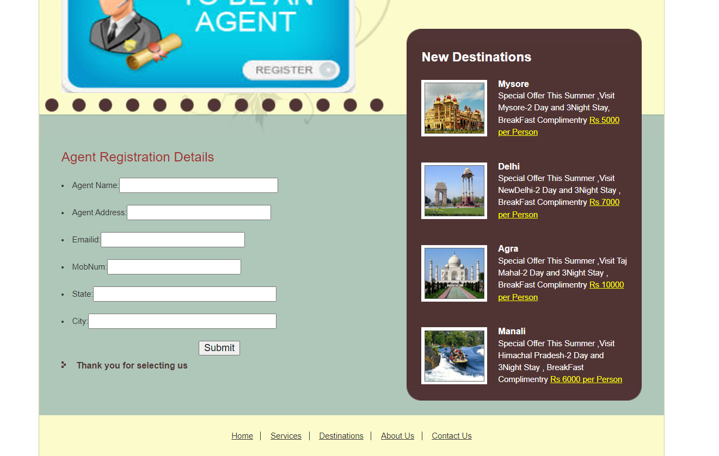

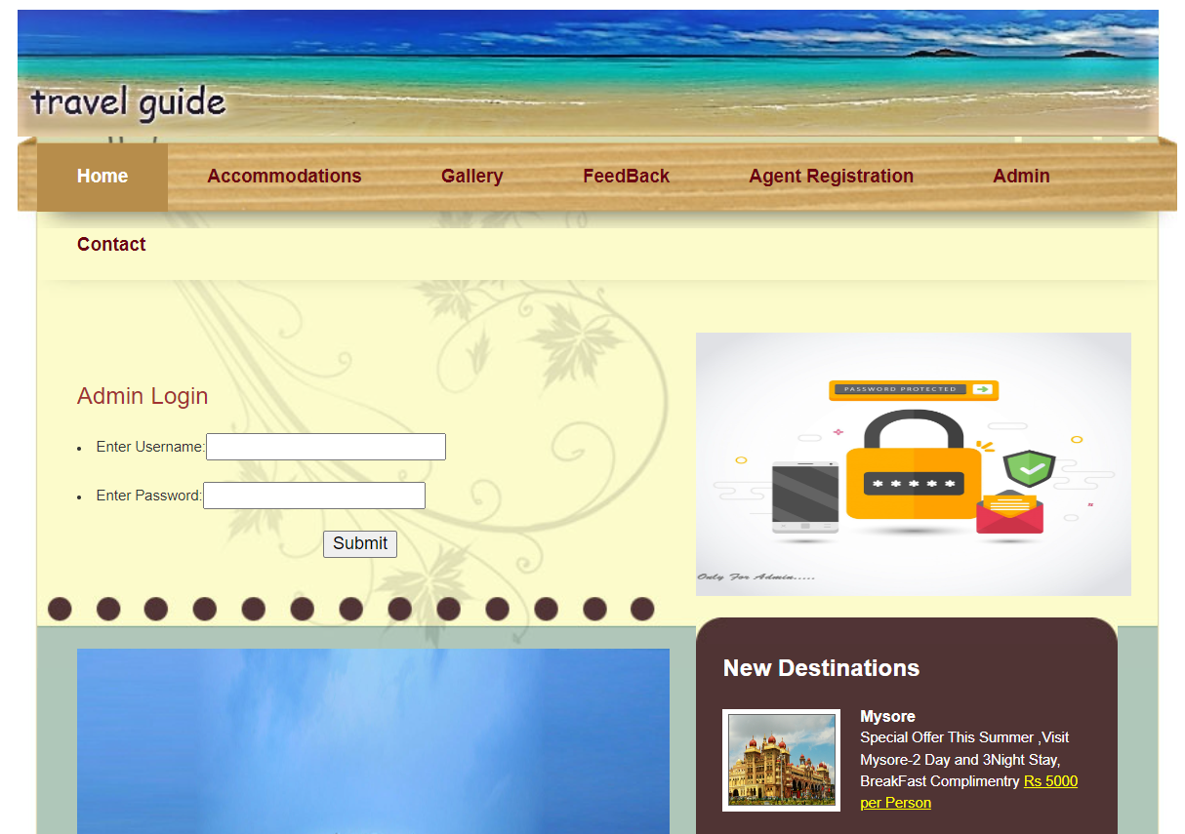

**Module 6: Notification System**

* Integrate email and/or SMS notification services.
* Develop triggers and notifications for appointment reminders, new bookings, and cancellations.
* Implement a system for handling and tracking notifications.
* Output screenshot:

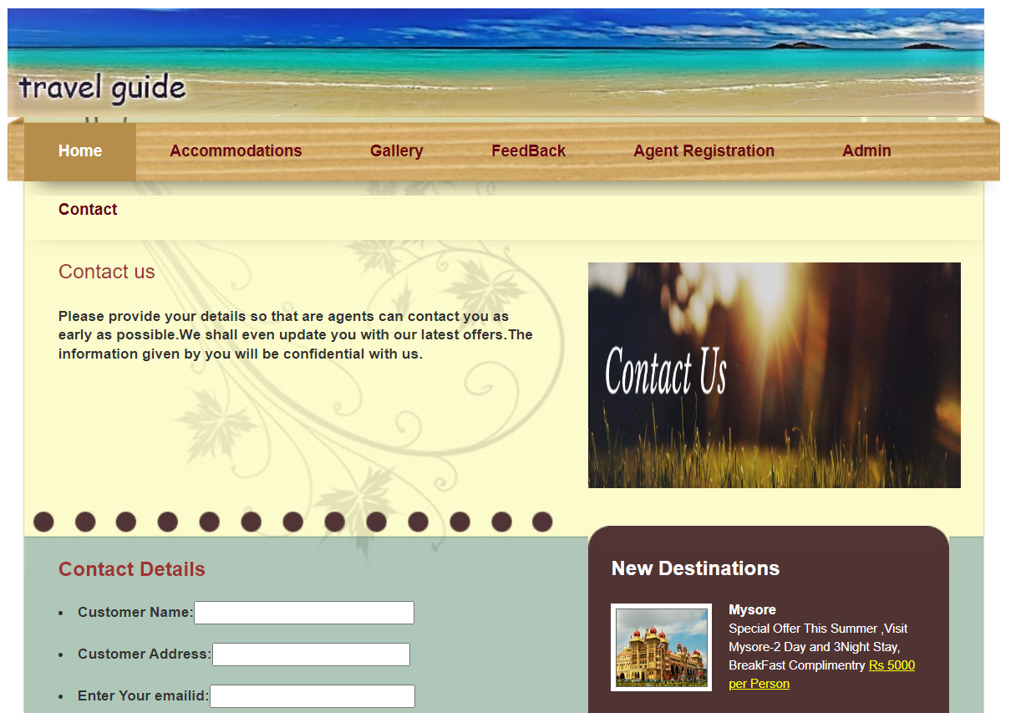

**Module 7: Admin Dashboard**

* Design the layout and functionality of the admin dashboard.
* Implement user management features for admins to add, edit, and delete users.
* Develop modules for managing visiters and give place information.
* Output Screenshot:

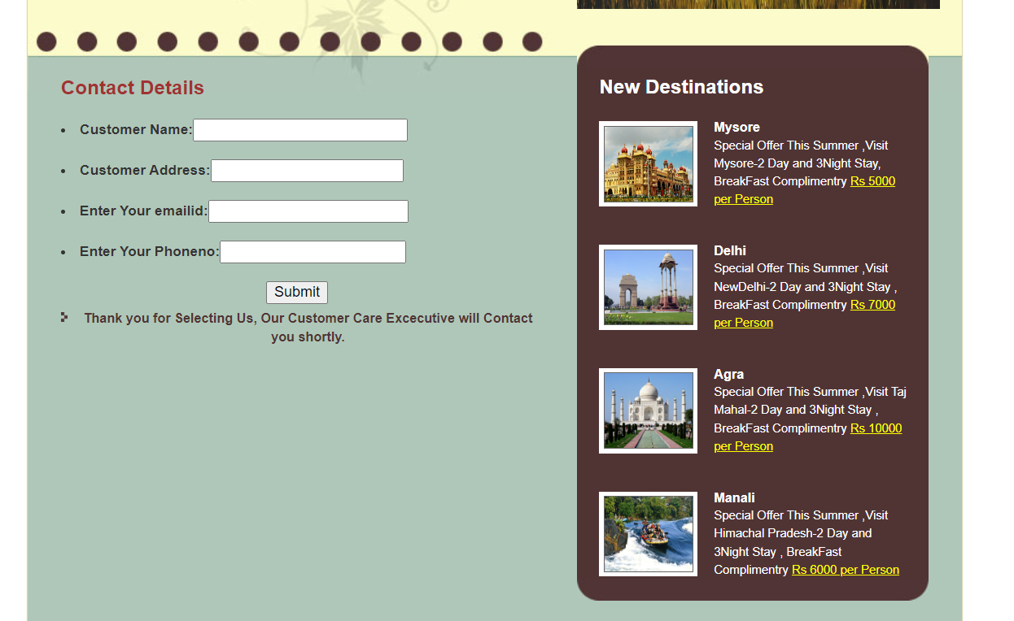

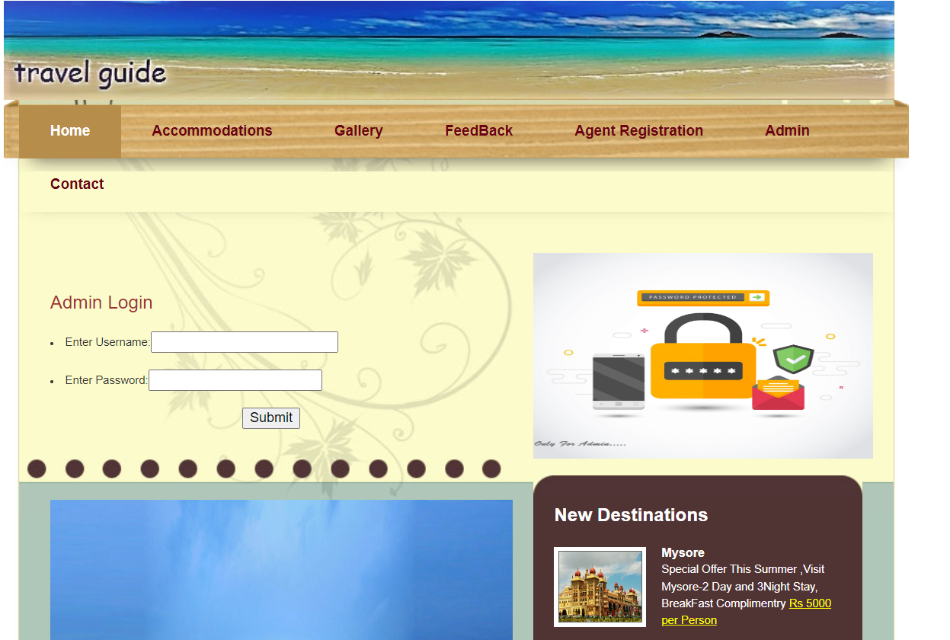

**Evaluation Criteria:**

**Milestone 1 Evaluation (Week 3):**

* Completion of user authentication and registration.
* Successful implementation of doctor availability management functionalities.

**Milestone 2 Evaluation (Week 5):**

* Appointment scheduling interface is fully developed and integrated with the backend.

**Milestone 3 Evaluation (Week 7):**

* Appointment management system is operational, allowing for scheduling and viewing appointments.

**Milestone 4 Evaluation (Week 10):**

* Patient information management, notification system, and admin dashboard are fully implemented and functional.

1. Design diagrams

Class Diagram: Entity classes

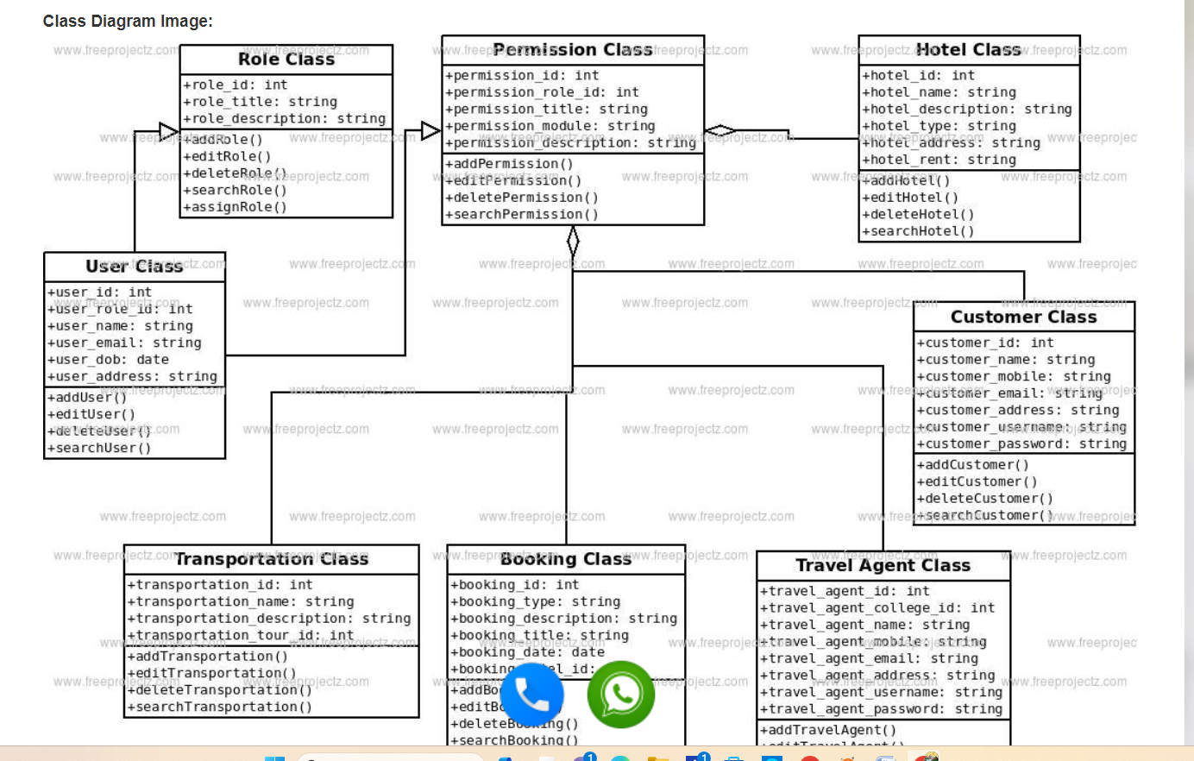

**Output Screenshots:**

1. Dashboard

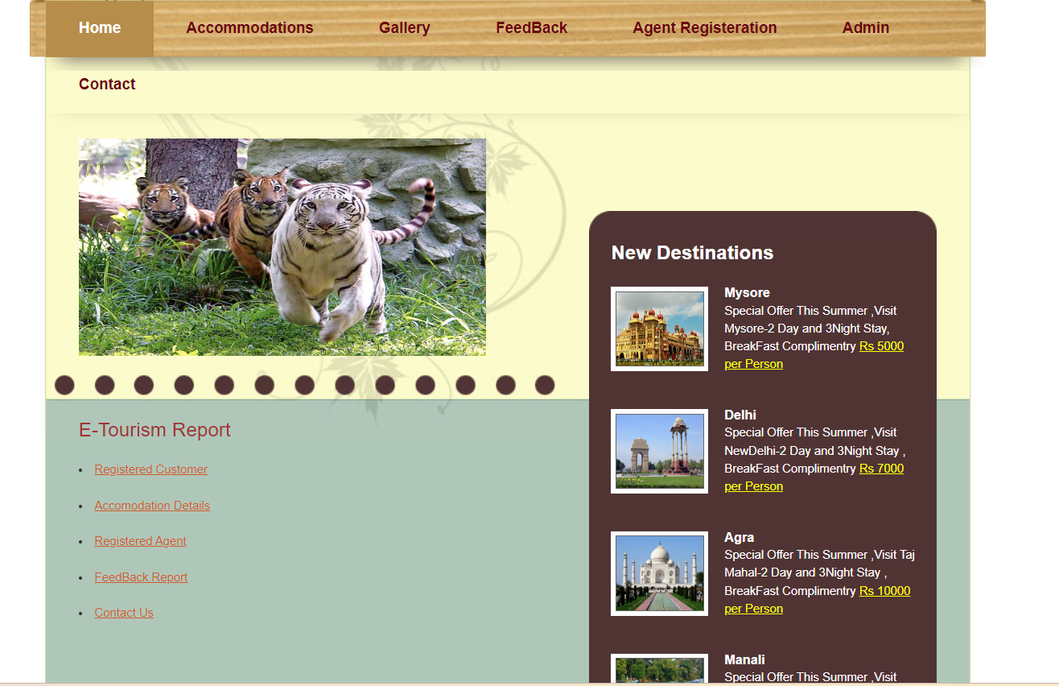

2. Admin Dashboard

